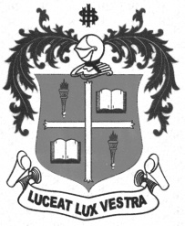
LOYOLA COLLEGE (AUTONOMOUS), CHENNAI – 600 034
M.A. DEGREE EXAMINATION - APPLIED HISTORY
FIRST SEMESTER – NOVEMBER 2012

HT 1812 - WORLD CIVILIZATION

Date : 09/11/2012 Dept. No. Max. : 100 Marks

Time : 1:00 - 4:00

Part-A (4x5=20 Marks)

Answer any FOUR of the following in 100 words each:

- D.D. Kosambi
- Mother Goddess
- Crusades
- Education a social control
- Gospel of Humanism
- New Continents

Part-B (2x10=20 Marks)
Answer any TWO of the following in 200 words each:

- Give an account on the comparison between Culture and Civilization.
- Assess the Babylonian civilization and its contributions.
- Narrate the significance of education in making the world of Civilization.
- Write a short note on the role of Philosophers during the French Revolution.

Part-C (3x20=60Marks)

Answer any THREE of the following in 1200 words each:

- Discuss the Toynbee view on Culture and Civilization.
- Describe the rise and fall of Indus Civilization.
- How did the art of writing develop in various civilizations?
- Martin Luther King Jr., enjoys rare honour in the minds of the Blacks’ - Justify.
- United Nations is a myth or a reality- Discuss.

@@@@@@

